#### **Humanitarian Service Directory for Palestinian People, State of Palestine, 2025**

#### Objective and guidance notes

**Humanitarian Service Directory for Palestinians**

**Enhancing Accountability and Engagement in Palestine**

**Overview**

The Humanitarian Service Directory for Palestinians was developed by OCHA as an in-kind contribution to the Accountability to Affected Population (AAP) project implemented by UN Women and funded by the Central Emergency Relief Fund (CERF) to enhance accountability and community engagement at the collective level in the State of Palestine.

### **Key Features of the Service Directory**

* **Comprehensive Information**
  + Provides essential information for affected populations, including:
    - Key messages
    - Details on physical and online services
    - QR codes for registration forms
    - Contact information for specialized support
    - Options for providing feedback on aid and aid workers
* **Awareness Materials**
  + Allows the creation of awareness-raising content tailored to:
    - Specific geographic areas
    - Types of services
    - Target groups
  + Provides a central hub for:
    - Social media cards
    - Brochures
    - Flyers
    - Other materials prepared by partners
* **Repository for Humanitarian Information**
  + Houses vital data to help humanitarian actors:
    - Lists effective communication channels for reaching affected people
    - Hosts key public perception reports and social media trend analyses from the UN Women AAP CERF Project
* **Trend Reporting & Cluster Coordination**
  + Enables helpline operators and aid workers to submit common questions or emerging trends, automatically forwarding them to cluster coordinators for responses.
  + Helps overcome challenges like:
    - Staff turnover
    - Lack of updated contact details for cluster coordinators
    - Ensures timely, documented, and tracked responses
* **Supporting Community Feedback Mechanism (CFM)**
  + Reduces case traffic to clusters by providing information that allows for on-the-spot case closures.
  + Consolidates information to assist helpline operators in addressing frequent queries efficiently.
* **Addressing Key Challenges**
  + Helps resolve issues such as:
    - Inconsistent service information
    - Communication breakdowns
    - High staff turnover in short-term deployments
  + Centralizes critical service data to improve coordination and response effectiveness.

### **Benefits of the Service Directory**

* **Empowers Humanitarian Organizations**
  + Supports real-time, accountable community engagement across different areas.
  + Strengthens collective AAP efforts by addressing identified gaps in humanitarian response activities.
* **Reduces Workload for Partners**
  + Consolidates and amplifies awareness-raising materials, reducing the need for individual partners to create their own content.
* **Improves Coordination and Response**
  + Facilitates efficient information sharing, timely responses, and better coordination across all humanitarian activities in the region.

### **Link to tool:**

* The link to the tool: [https://opt-aap-iasd.azurewebsites.net/login](https://eur02.safelinks.protection.outlook.com/?url=https%3A%2F%2Fopt-aap-iasd.azurewebsites.net%2Flogin&data=05%7C02%7Chuseina%40un.org%7C006ca748ae144c6f51ff08dcf8c88f71%7C0f9e35db544f4f60bdcc5ea416e6dc70%7C0%7C0%7C638658787479086314%7CUnknown%7CTWFpbGZsb3d8eyJWIjoiMC4wLjAwMDAiLCJQIjoiV2luMzIiLCJBTiI6Ik1haWwiLCJXVCI6Mn0%3D%7C0%7C%7C%7C&sdata=7Tf%2B2UtLeG44g%2FZ%2FSDIL65HZd4k2JPQFsEL8rimDZt4%3D&reserved=0) . No need to create an account just yet just click on LOG In to access the system.

### **Key features**

* **Comprehensive Information Sharing**

The directory consolidates services across multiple sectors functioning in the Gaza Strip and the West Bank. By centralizing this information in one accessible platform, it reduces the need for referrals and equips frontline workers with all the details they need to support affected populations effectively.

* **Real-Time Updates**

Built to adapt to rapidly changing conditions, the directory ensures that updated information—such as changes in service locations or availability—is disseminated promptly.

* **Practical Field Utility**

The tool is tailored for use in the field, addressing common questions such as which services are operational in specific areas. It supports field staff in preparing for calls, visits, or creating awareness materials, streamlining interactions with affected communities.

* **Accountability and Oversight**

The directory includes protocols to ensure that the information shared is accurate and responsibly managed. Partners can update their service details as needed, fostering accountability and maintaining the tool’s reliability over time.

### **How it Works**

* The system gathers service details from all partners involved in the humanitarian response.
* Field staff can use the directory to provide real-time, accurate information during interactions with affected populations.
* Each partner is responsible for keeping their service information up to date. For partners facing challenges, such as connectivity issues in Gaza, OCHA colleagues can manage updates on their behalf.

**Step-by-Step Tool Guide**

**SERVICES**

**Purpose of the Services section**

The Services section offers a comprehensive directory of available services in Gaza and the West Bank. It is a vital resource for helpline operators and humanitarian actors to provide precise and relevant information in response to inquiries.

**How to Find a Service**

Users can filter services by criteria such as cluster, organization, service type, region, and community. They can also export service data for offline use, including comprehensive details like contact information, operational hours, and service availability. The export feature is also available for the Messages and Helplines sections.

**Type of information**

Services include as much information as the organization can provide, such as the provider, the region, governorate, and community where the service is available, the focal point's contact details, telephone numbers, and the days and hours of operation. The more detailed the information, the more accurately users can respond to callers' needs.

Below are three examples of Protection – GBV services, showcasing diverse details to help locate and contact services efficiently.

**How to Add/ Edit a Service**

Organizations can manage the services listed in the tool to ensure the information remains accurate and up-to-date. By clicking on the **Edit** button in the top-left corner of the tool, organizations can add new services, edit existing ones, or delete those no longer in place.

To add a new service, partners need to include all the information available about that service; the more details provided, the more accurate the information helpline operators can relay to callers.

The name of the organization providing the service needs to be added manually under *Provider*. There is no drop-down list of service providers maintained by OCHA for the directory.

To edit an existing service, organizations can scroll down on the edit page to see the list of services. Next to each service listed, there are two icons.

By clicking on the **pen icon**, users can modify the service details, which will automatically update in the list.

**How to Delete a Service**

If a service needs to be removed, clicking on the **bin icon** will delete it, and it will no longer appear in the list.

This process ensures that the services database remains current and reliable, enabling helpline operators to provide the best possible assistance.

**TOP LINE MESSAGES**

**Purpose of Top Line Messages section**

The Community Engagement Messages section serves as a platform for clusters and partners to share messages containing essential information and guidance intended for dissemination to the affected communities through various channels.

These messages can be utilized for activities such as awareness sessions, radio broadcasts, or social media campaigns, ensuring that critical information reaches affected populations effectively.

**Who can Add a Top Line Messages**

Messages intended for publication on the directory on behalf of a cluster must receive prior approval from the Cluster Coordinator, while those posted on behalf of an organization require authorization from the organization’s designated focal point. This approval process ensures that all messages are accurate, appropriate, and aligned with the priorities of the cluster or organization.

**How to Find a Top Line Messages**

Users can filter the messages by cluster, organization, service, and governorate, enabling efficient navigation and retrieval of relevant content.

For illustrative purposes, examples of messages amplified by the Health Cluster are provided below, demonstrating the range of information shared through this platform.

**How to Edit a Add/Edit Top Messages**

Organizations can manage the messages featured in this section to maintain accuracy and relevance. By selecting the **Edit Messages** option, users are able to add new messages, update existing ones, or remove messages that are no longer applicable. The process for managing messages is consistent with the procedures outlined in the Services section. When submitting a new message, organizations should provide all pertinent details, including the message content in English and Arabic languages, the service related and intended purpose relevant note? , to ensure clarity and effectiveness.

To edit an existing message, users can click on the **edit icon**, where the content will become editable and will automatically update upon saving.

**How to Delete Top Line Messages**

To delete a message, users may select the **delete icon**, which will remove the message from the list. Below the editing interface, examples of AAP messages in both English and Arabic are presented, showcasing how messages are displayed along with the respective editing and deletion options.

This structured approach ensures that messages are accurate, up-to-date, and readily accessible for use in community engagement initiatives.

**HELPLINES**

**Purpose of the Helplines section**

There are multiple helplines dedicated to the Palestinian population. Many helplines are specialized, in other words, they are operated by people who provide specialized support to callers, such as MHPSS, GBV, and Health. Some helplines are dedicated to different gender groups and types of feedback and or complaints.

It is common that people may not distinguish between the different helplines and therefore may call to request help or support or information that does not necessarily pertain to the particular helpline or may call for multiple purposes. The Helpline operator may come to realize during a call that the caller needs various types of support. Therefore, it is crucial that helpline operators have access to all information regarding specialized helplines and services so that they can refer people to the correct addresses/ information to support the caller.

For the same purposes, the Humanitarian Service Directory for Palestinians hosts all information regarding the existing helplines, and who they service. The Helplines section provides a list of free helpline services that offer essential support to communities in need. Organizations have the ability to add or update helpline details, specifying the service provided, the location, contact information, operating days and hours, and the intended audience (e.g., adults, children).

**How to Search for a Specific Helpline**

Helplines can be filtered by cluster, organization, service, and governorate, allowing for efficient retrieval of relevant information.

As with the Services and Messages sections, organizations can add new helplines, modify existing entries, or remove outdated or incorrect listings following the same procedures.

**How to Add/Edit a Helpline**

To add a new helpline, organizations must ensure that all relevant details are provided to ensure clarity and accessibility for helpline operators and callers. When editing an existing helpline, users can update the necessary fields, which will automatically reflect the changes in the list.

**How to Delete a Helpline**

To delete a helpline, users may select the **delete icon**, and the service will be removed from the list.

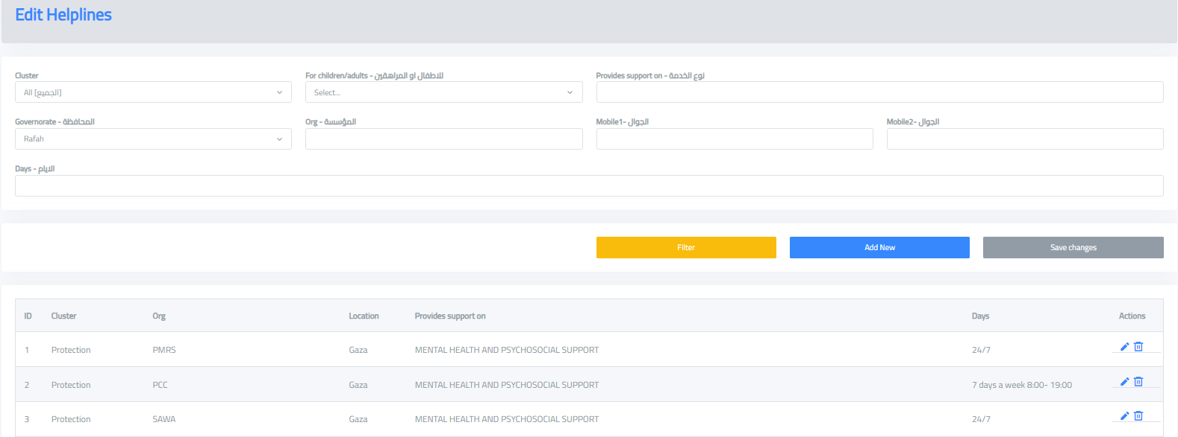

This approach ensures that helplines are accurately represented and accessible to those who need them, contributing to effective community support and response efforts.

**QUESTIONS & ANSWERS**

**Purpose of the Q&A section**

The *Questions and Answers (Q&A)* section provides a dedicated space for helpline operators and users to engage with cluster coordinators and thematic focal points, facilitating timely responses to inquiries.

The questions and answers can be filtered by cluster, organization, and region to streamline this process.

When operators receive a question that is not already addressed in the platform, particularly if it is a recurring query, they should first check the Q&A section to determine if the question has already been answered, as shown in the examples below.

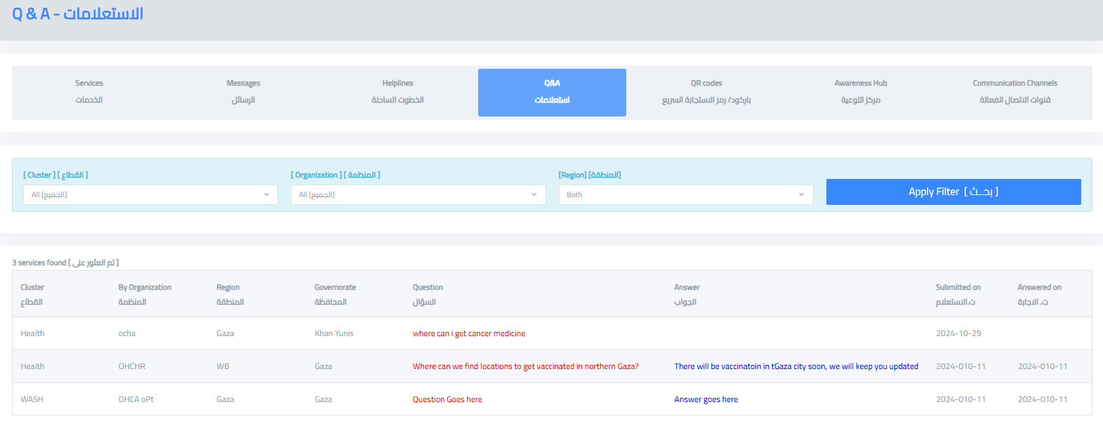

If the question has not been addressed, operators can submit a new question. It is crucial to select the correct cluster when submitting the query, as the message will be directed to the appropriate Cluster Coordinator or thematic focal point.

**How to Send a Question**

By clicking the **"Add New"** button, an email message will pop up, automatically including the question in the body text and the relevant focal point's email address in the CC field. This ensures that the right individuals are notified and can provide a timely response.

Below there is an example of a query directed to the AAP focal point.

**QR CODES**

**Purpose of the QR Codes Section**

The QR Codes section provides direct links to forms from clusters and partners, such as registration forms, making it easier for helpline operators to assist individuals in completing necessary paperwork or share links directly.

These QR codes can be filtered by cluster to streamline the search process.

**How to Add/Edit/Delete a QR Code**

To add a new QR code or update an existing one, users must upload a file containing the QR code. This functionality allows organizations to ensure that helpline operators have immediate access to the latest forms, facilitating efficient support for individuals requiring assistance.

This process ensures that the most relevant and up-to-date forms are easily accessible

By clicking on the edit icon, a QR code can be changed. By clicking on the delete icon, a QR code can be removed.

**AWARENESS Raising Material HUB**

**Purpose of the Awareness Raising Material HUB**

The Awareness Materials section allows users to access and upload a variety of materials, such as brochures, social media graphics, posters, and other awareness products, which can also be printed for distribution. The primary objective of this section is to make awareness materials easily accessible to all users, thereby supporting and amplifying the efforts of clusters and partners in their community outreach activities.

These materials can be filtered by cluster, region, and type to facilitate efficient access.

**How to Add/Edit/Delete an Awareness Raising Material**

Similar to the *QR Codes* section, users who wish to add new materials or update existing ones are required to upload the relevant file. This process ensures that all users have access to the most current and appropriate awareness materials to enhance their engagement and outreach initiatives.

By clicking on the edit icon, an awareness raising material can be changed. By clicking on the delete icon, an awareness raising material can be removed.

**LIST OF VIABLE COMMUNICATION CHANNELS**

The Communication Channels section provides a comprehensive list of available communication channels, including radio stations that are the most heard and broadcasting in Gaza and the West Bank. These channels serve as key tools for disseminating information and engaging with communities.

|  |
| --- |
| **Target Audience: Gaza public** |
| Options for sharing informed by operational reality on the ground: |
| SMS Text Messaging  This is currently the most effective communication channel to reach people in Gaza. It is reserved for life saving messages. Reach out to [huseina@un.org](mailto:huseina@un.org) , OCHA oPt for support to utilize this option. |
| Share via radio stations that reach Gaza. This is a list updated as of 15 May based on inputs from operators on the ground from different. (source: Ooredoo Telecommunication Company), noting that strength fluctuates based on where people are located/elevation.  **Please feel free to inform the list and comment with a view of improving/validating the list.**   Radio station by strength:   * **89.8** Basma Radio Station * **103.2**, Palestine * **98.8** broadcasts Al Jazeera, only heard in north Gaza. * **93.9** AlOroba Radio Station, broadcasts Al Jazeera, only heard in middle area and south. * **88.3** Quran Kareem Radion Station, broadcasts from Nablus * **103.4** Ajyal Radio Station, broadcasts from Ramallah only heard in north.   **107.2** Ajyal Radio Station, broadcasts from Ramallah only heard in middle area and south. |
| Share with helpline operators and call centers to be able to share with people as needed. Consider playing as voice messages during call waiting intervals. |
| Share with humanitarian staff, implementing partners operating in Gaza for them to add to their printables/ stickers and share with people they interact with. |
| Post on your social media platforms: chatbots, applications with focus on telegram. |
| Print as stickers and place on humanitarian aid deliverables |

**Contacts of OCHA AAP team:**

* Amal Husein, [huseina@un.org](mailto:huseina@un.org)
* Alaa Abu Ramadan**,** [aburamadan@un.org](mailto:aburamadan@un.org)
* Blanca Royo Serrano, [blanca.royo-serrano@un.org](mailto:blanca.royo-serrano@un.org)